Keppel Land Customer Centricity Engagement

August 6, 2022

\

What you are focused on Achieving
We understand that there are very clear outcomes that you are focused on achieving in this engagement:
- Customer-centric approach and mindset.
- Engagement and alignment throughout the organization.
- Having the new approach, mindset, and processes to echo your mission, vision, and values
- Be relevant to customer, and support and compliment shifts in business model as you move to ‘asset-light’ portfolio, as well as new business development, such as Senior Living.
- Having a well-defined future state and playbook to ensure understanding, execution, and outcomes.

What You get From our Work
Given what you care about and what you are focused on, this is what we bring to make that become a reality:
- Discovery in the Current State that includes a deep dive into market conditions, market positioning (SWOT), current customer sentiment and segmentation, AND looking at your aspirational customer to become further future proofed.
- Define the Future; a Vision-to-Value Roadmap that clearly defines “the new way to work”
- Develop: A Playbook of Installing and Enhancing the:
Foundation: The New Way to Work
Framework: The Tools and Resources needed to make the uncommon habit
Focus: How to coach, manage, and hold accountable the new foundation to ensure business outcomes
- A proven and pragmatic approach that has brought business results in other organizations yet is customized to Keppel Land’s vision and values.
What bring enables and ensures:
- Chosen business outcomes.
- Customer Centric mindset that ‘future proofs’ the business.
- Be relevant to the customers that are the most valuable to you.
- Ability to flex and shift business without losing the foundation and customer centric approach.
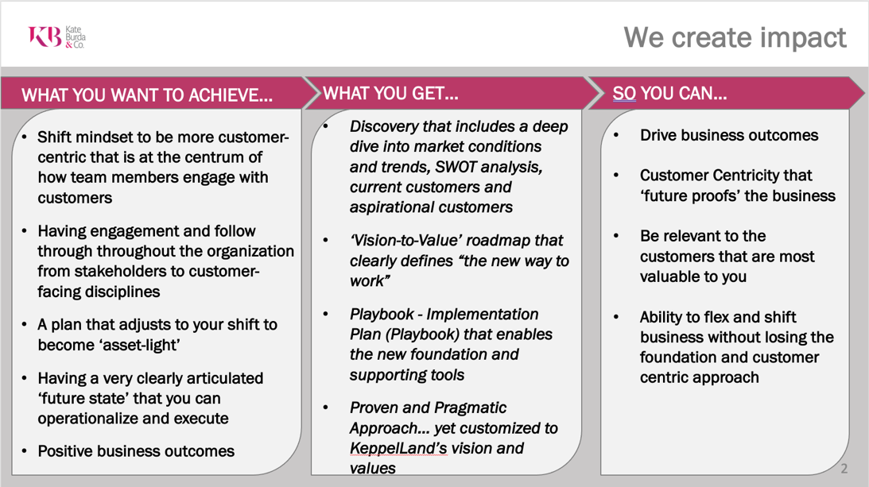

Customer Centricity

Customer Centricity: Your Differentiator
Insight 1: If you build a process without having knowledge of what your customer’s care about or what drives their satisfaction, you are not customer centric.
You have only created another internal message that may not be tied to your customers at all.

Customer Centricity is at the forefront of everyone’s mind. And many believe that they are, but they start the work thinking about their products and service. Which is on complete other side of the spectrum than what their customers care about or seek.
What the best do differently is understand to be customer focused organizations must have an outside in.
Outside in thinking takes a deep dive into what your customers value most, particularly the customers that are the most valuable to your business and strategic growth.

Shifting the mindset: The customer Centric Methodology

Where organizations fail in customer centric thinking is when they begin thinking about themselves first. Whether that is their products, services, processes, and even their values.
They start with thinking about themselves and then to the customer in explaining how they fit in to what the customer. See figure 1. When teams work from left to right, they are only trying to convince customers and ultimately themselves that what they have is what the customers need. (The solid line)
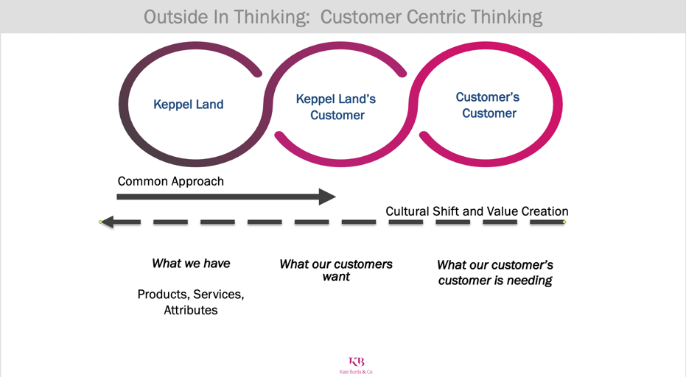
We take a completely different approach and not only look at the customer, but the customer’s customer. Working from right to left. (The dash line.) This is a cultural shift and creates value for our the customer.
And is truly customer centric.
Here is an example:
A golfer, possibly one that is going to visit Spring City Golf. In the approach we see often that is less customer centric, they start talking about the golf course, the designer, the events they have hosted, the list goes on.
But if reverse engineer to create value we would look at the customer’s customer. In this example it is the family. What the family cares about is having memories and creating experiences. Working left we understand that they golfer may care about bragging about where they played or checking off box of courses or places they placed. This outside in thinking changes how we engage, approach, and see our customers differently.
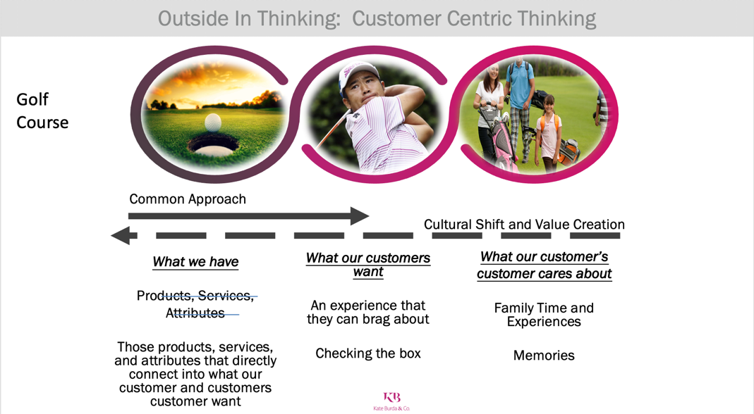
Insight 2: Why is the customer’s customer so important to our customer-centricity work? Because if we make our customers and clients successful, important, and valued by their customer, they will become a lifetime customer of Keppel Land.

This thinking and approach is core to how we define and develop the Keppel Customer Engagement model.

Strategic Engagement Pathway
Below illustrates the pathway that has worked in programs very similar to Keppel Land to ensure impact:
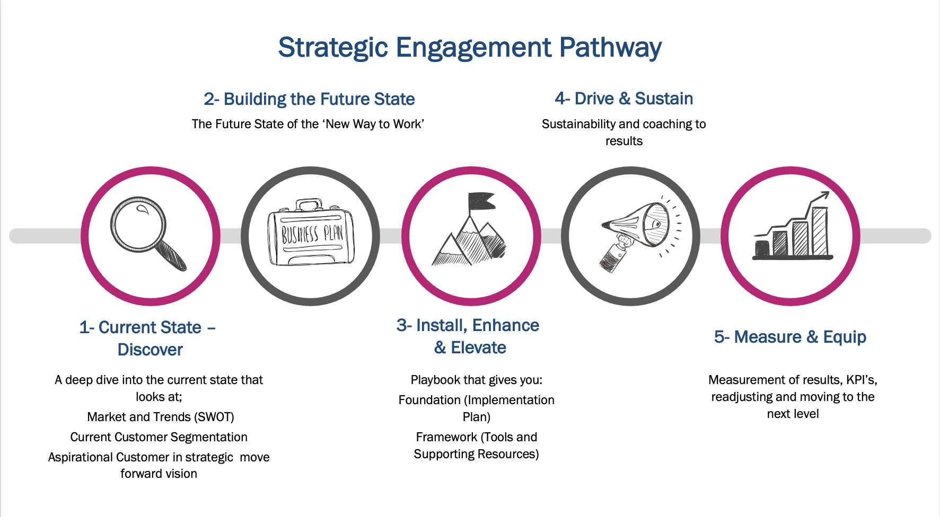

Current State- Discovery

